* **Organization of pages:**

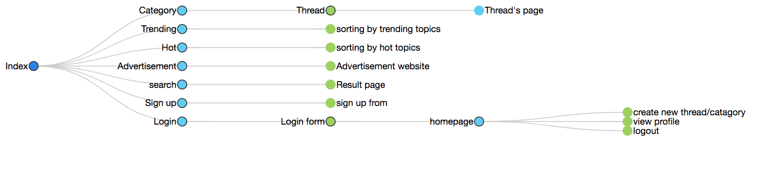

* **Logic process**
* Visitors(not users): visitors will be able to view post/threads and register.
* Users: users will be able to post threads and create new categories as well as commenting on their and others threads. View their profile and make changes to certain info (i.e. email and avatars etc.…).
* Creating an account: name, email username, avatar(optional).
* **Layout document**

Attached.